DIGITAL ELECTRONICS AND LOGIC DESIGN [EC - 207]

**SARDAR VALLABHBHAI NATIONAL INSTITUTE OF TECHNOLOGY, SURAT ELECTRONICS ENGINEERING DEPARTMENT**

## BCD TO EXCESS-3 AND EXCESS-3 TO BCD CONVERTOR

**AIM:** To design and implement BCD to EXCESS -3 code converter using Multi-sim.

**SOFTWARE TOOLS / OTHER REQUIREMENTS:**

1. Multisim Simulator.

**THEORY:**

The Excess-3 binary code is an example of a self- complementary BCD code. A self-complementary binary code is a code which is always complimented in itself. By replacing the bit 0 to 1 and 1 to 0 of a number, we find the 1's complement of the number. The sum of the 1'st complement and the binary number of a decimal is equal to the binary number of decimal 9.

The process of converting BCD to Excess-3 is quite simple from other conversions. The Excess-3 code can be calculated by adding 3, i.e., 0011 to each four-digit BCD code. Below is the truth table for the conversion of BCD to Excess-3 code. In the below table, the variables A, B, C, and D represent the bits of the binary

numbers. The variable 'D' represents the LSB, and the variable 'A' represents the MSB. In the same way, the variables w, x, y, and z represent the bits of the Excess-3 code. The variable 'z' represents the LSB, and the variable 'w' represents the MSB. The 'don't care conditions' is expressed by the variable 'X'.

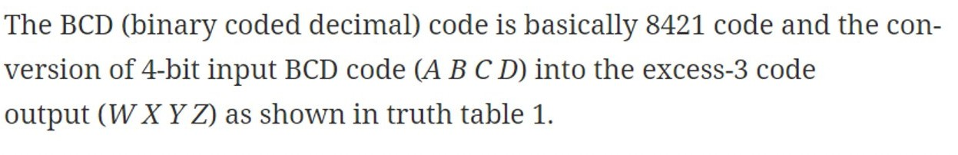

Truth Table - 1

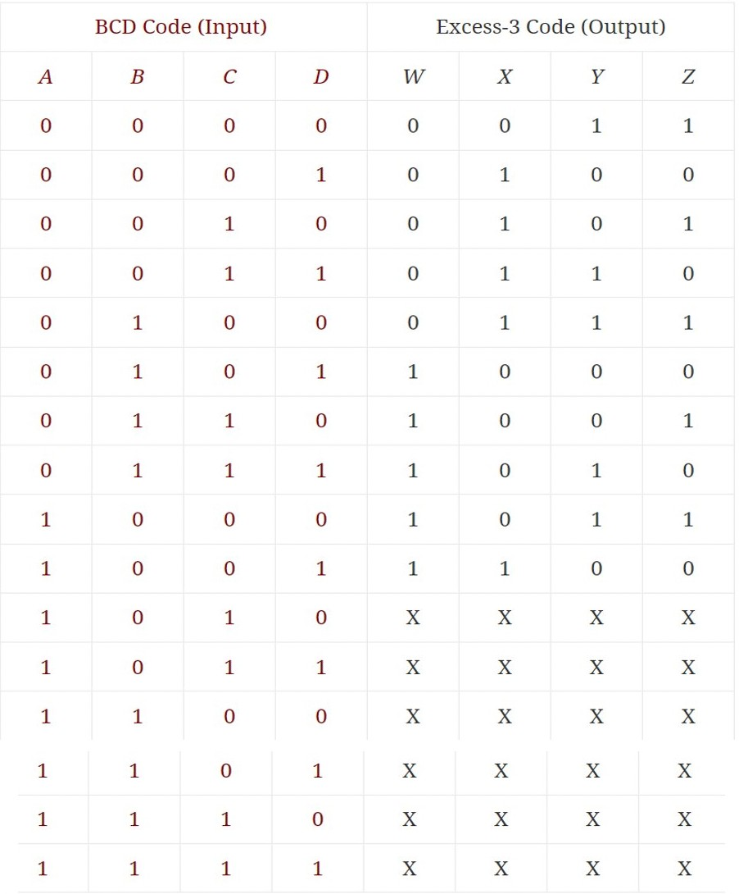

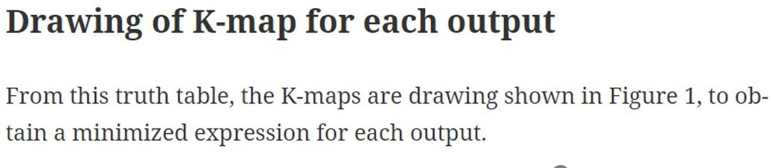

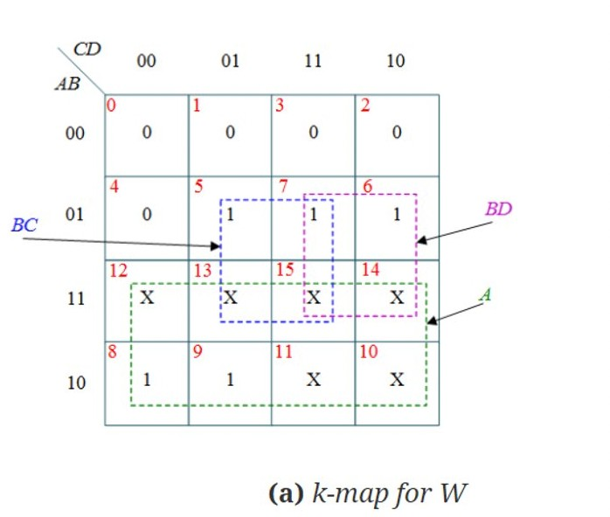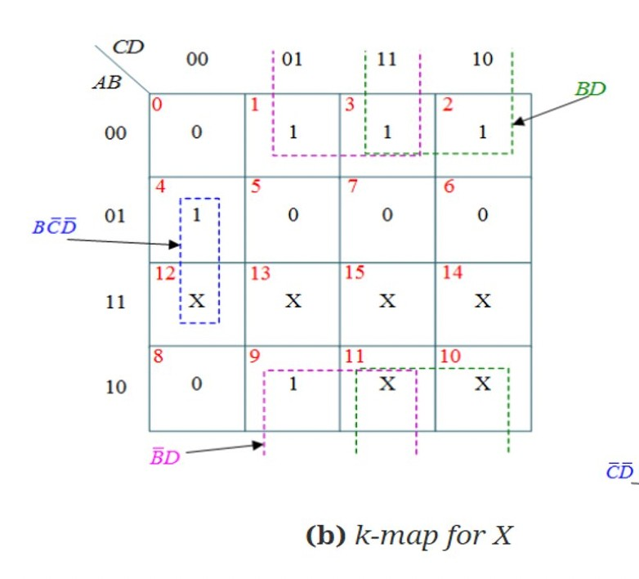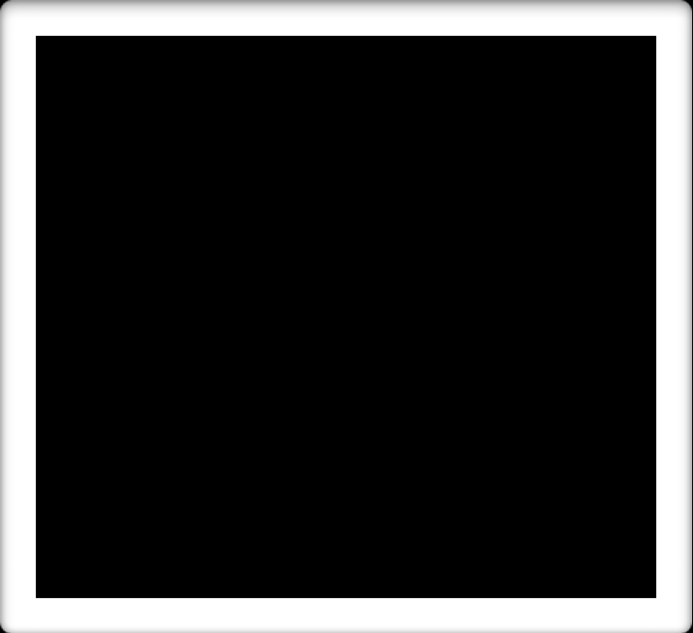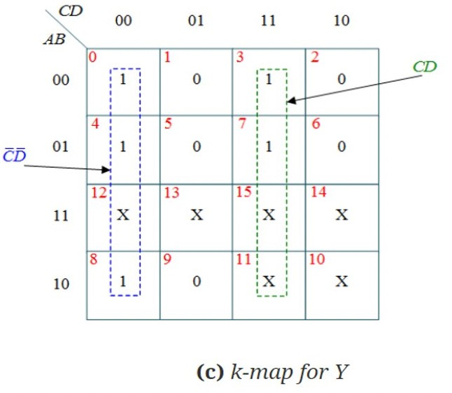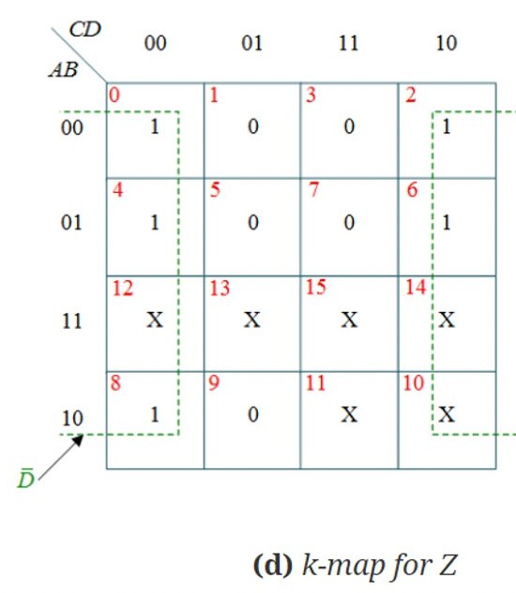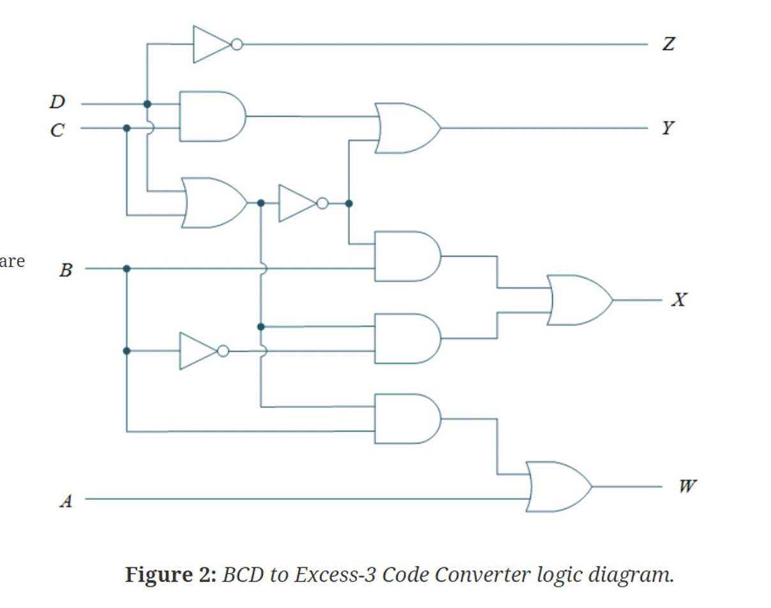

Minimized Version of Output :-

w=A+BC+BD

x=B' C+B' D+BC' D' y=CD+C'D'

z=D'

**LOGIC CIRCUIT DIAGRAM**

# Excess-3 to BCD conversion: -

The process of converting Excess-3 to BCD is opposite to the process of converting BCD to Excess-3. The BCD code can be calculated by subtracting 3, i.e., 0011 from each four-digit Excess-3 code. Below is the truth table for the conversion of Excess-3 code

Truth Table - 2

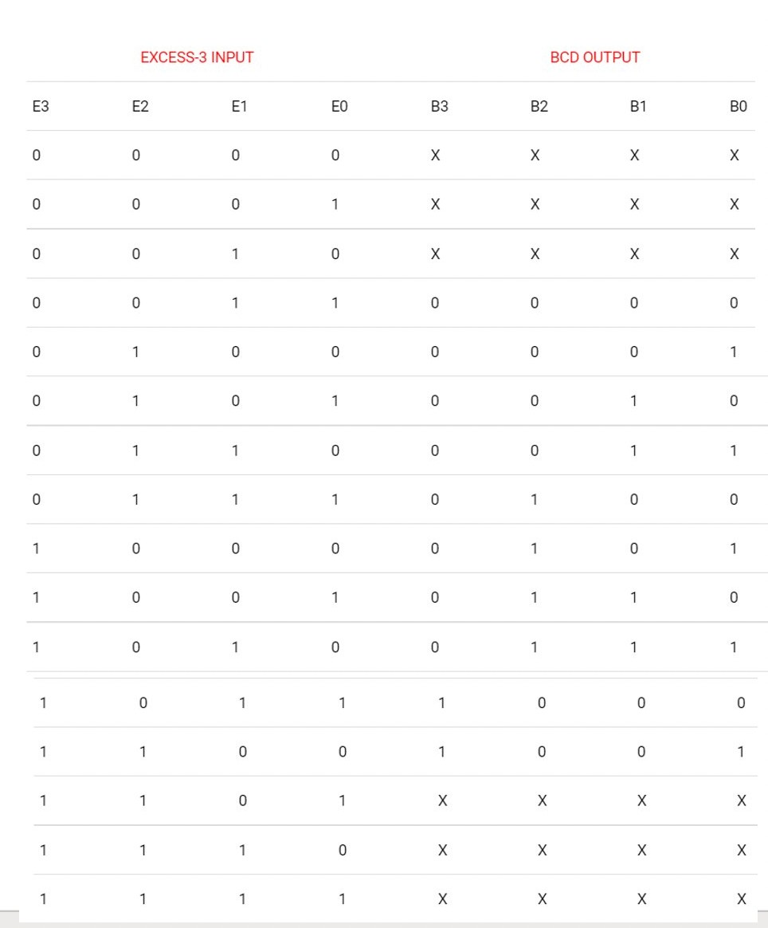

to BCD. In the below table, the variables w, x, y, and z represent the bits of the Excess-3 code. The variable 'z' represents the LSB, and the variable 'w' represents the MSB. In the same way, the variables A, B, C, and D represent the bits of the binary numbers. The variable 'D' represents the LSB, and the variable 'A' represents the MSB. The 'don't care conditions' is defined by the variable ‘X'.

Now, we will use the K-map method to design the logical circuit for the conversion of BCD to Excess-3 code as:

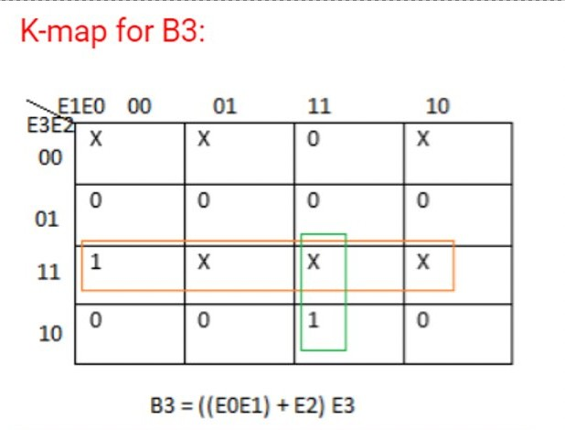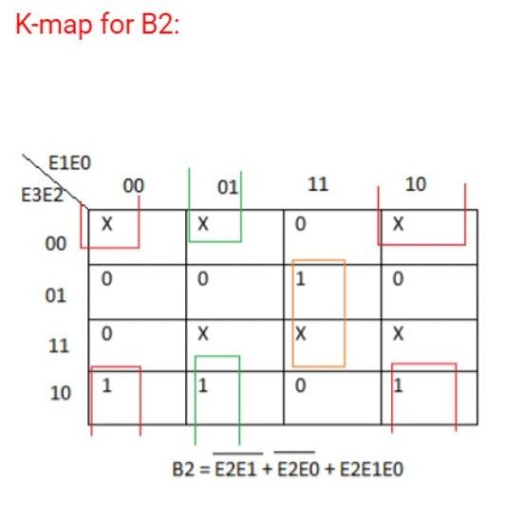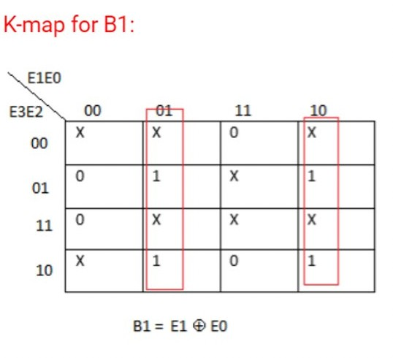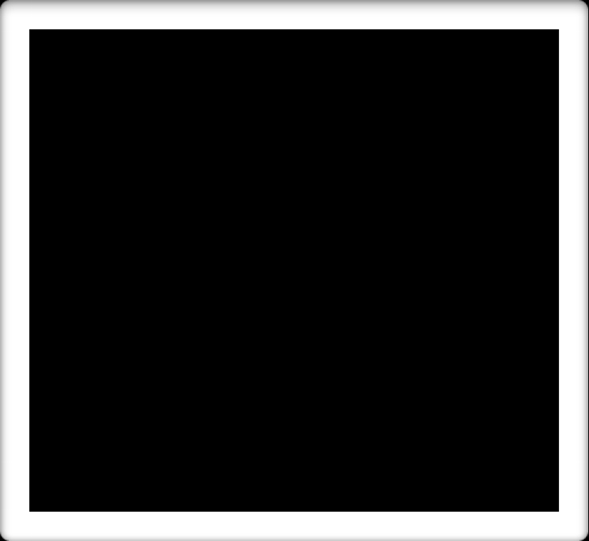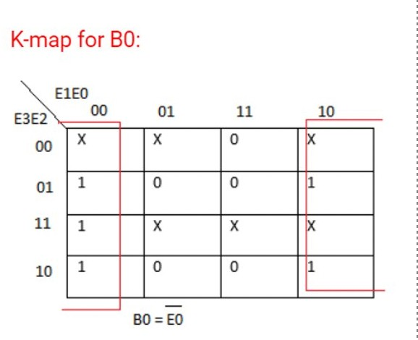

Minimized Version of Output :-

w=AB+ACD

B=x' y'+x' z'+xyz C=y' z+yz'

D=z'

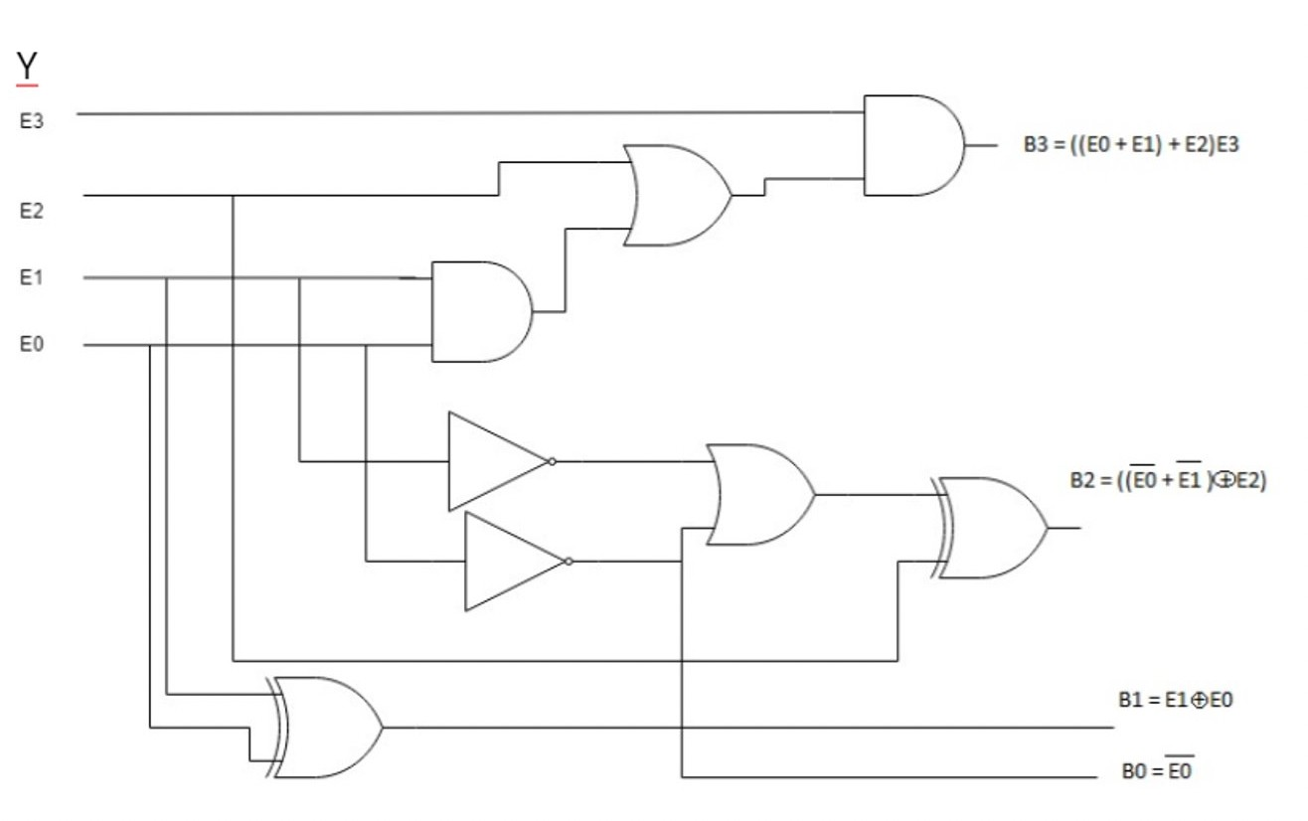

# LOGIC CIRCUIT DIAGRAM

**CIRCUIT/CONNECTION DIAGRAMS (FROM MULTISIM) ALONG WAVEFORMS (FROM MULTISIM)**

**BCD TO EXCESS-3 CIRCUIT: -**

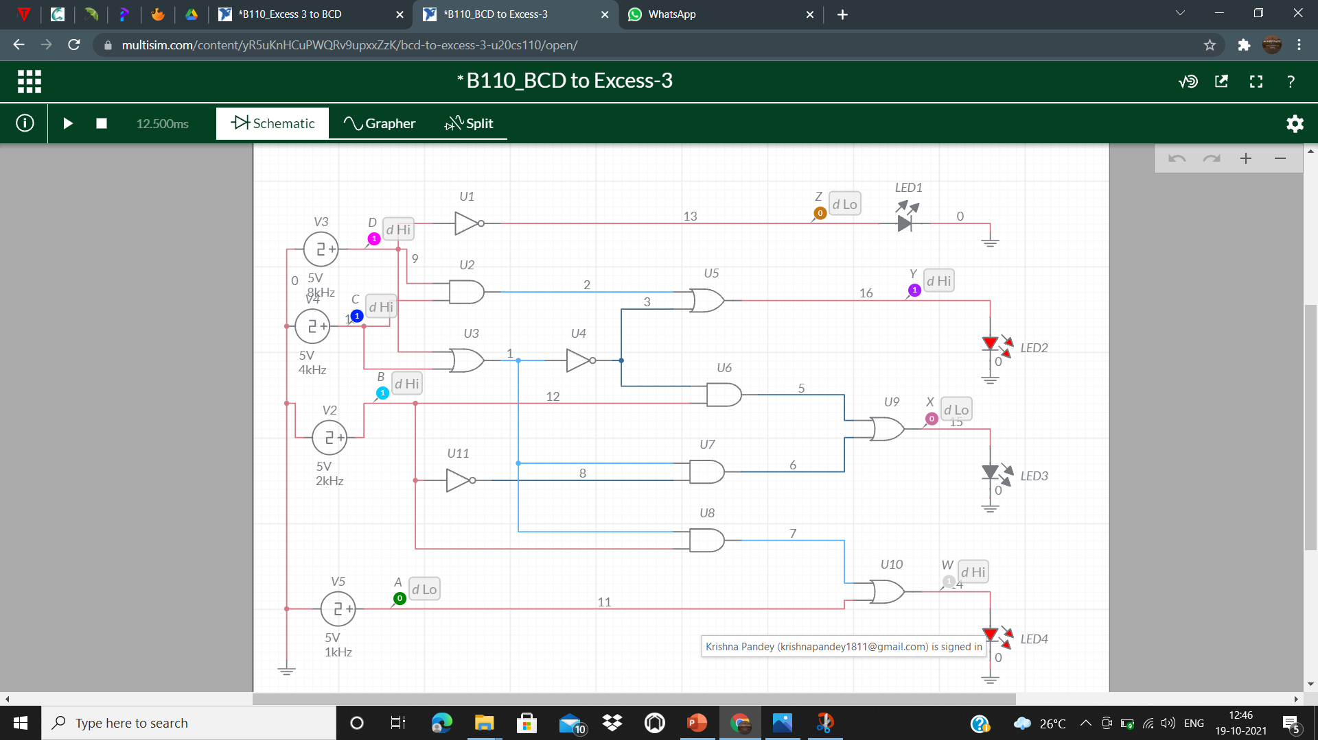

**BCD TO EXCESS-3 OUTPUT: -**

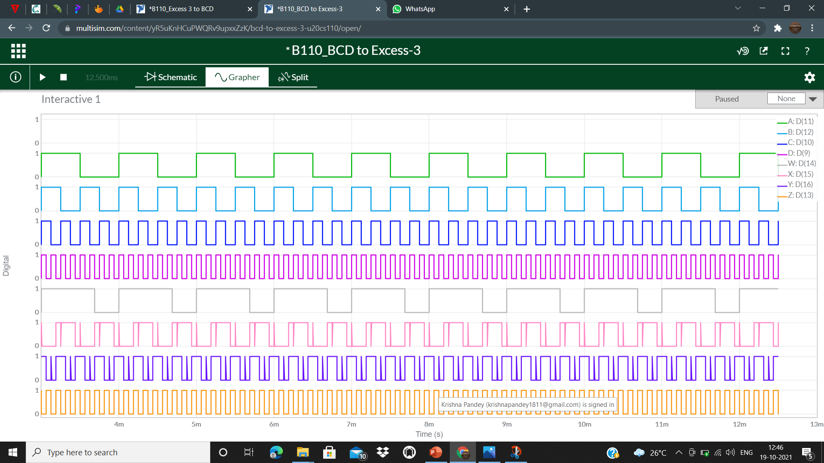

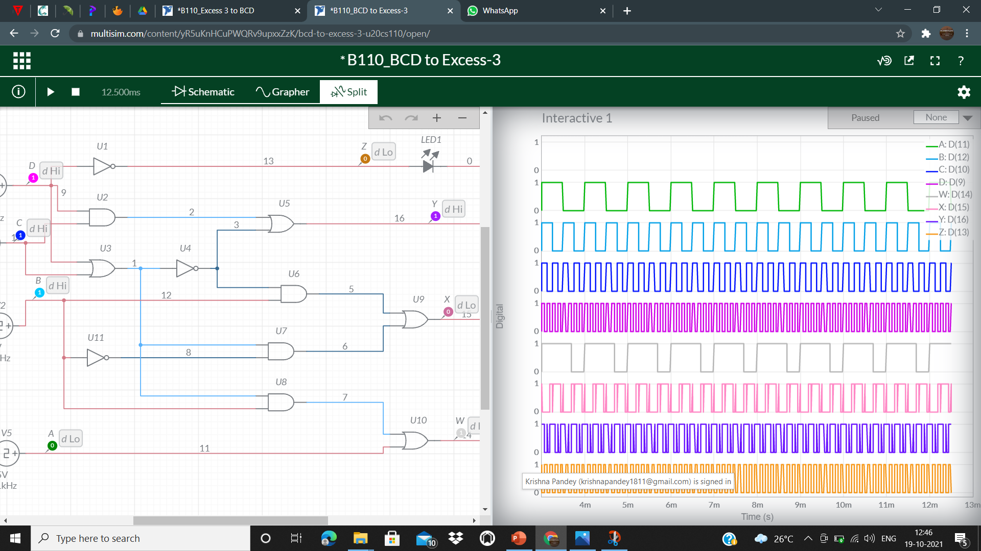

**CIRCUIT/CONNECTION DIAGRAMS (FROM MULTISIM) ALONG WAVEFORMS (FROM MULTISIM) ASSIGNMENT**

**EXCESS-3 TO BCD CIRCUIT: -**

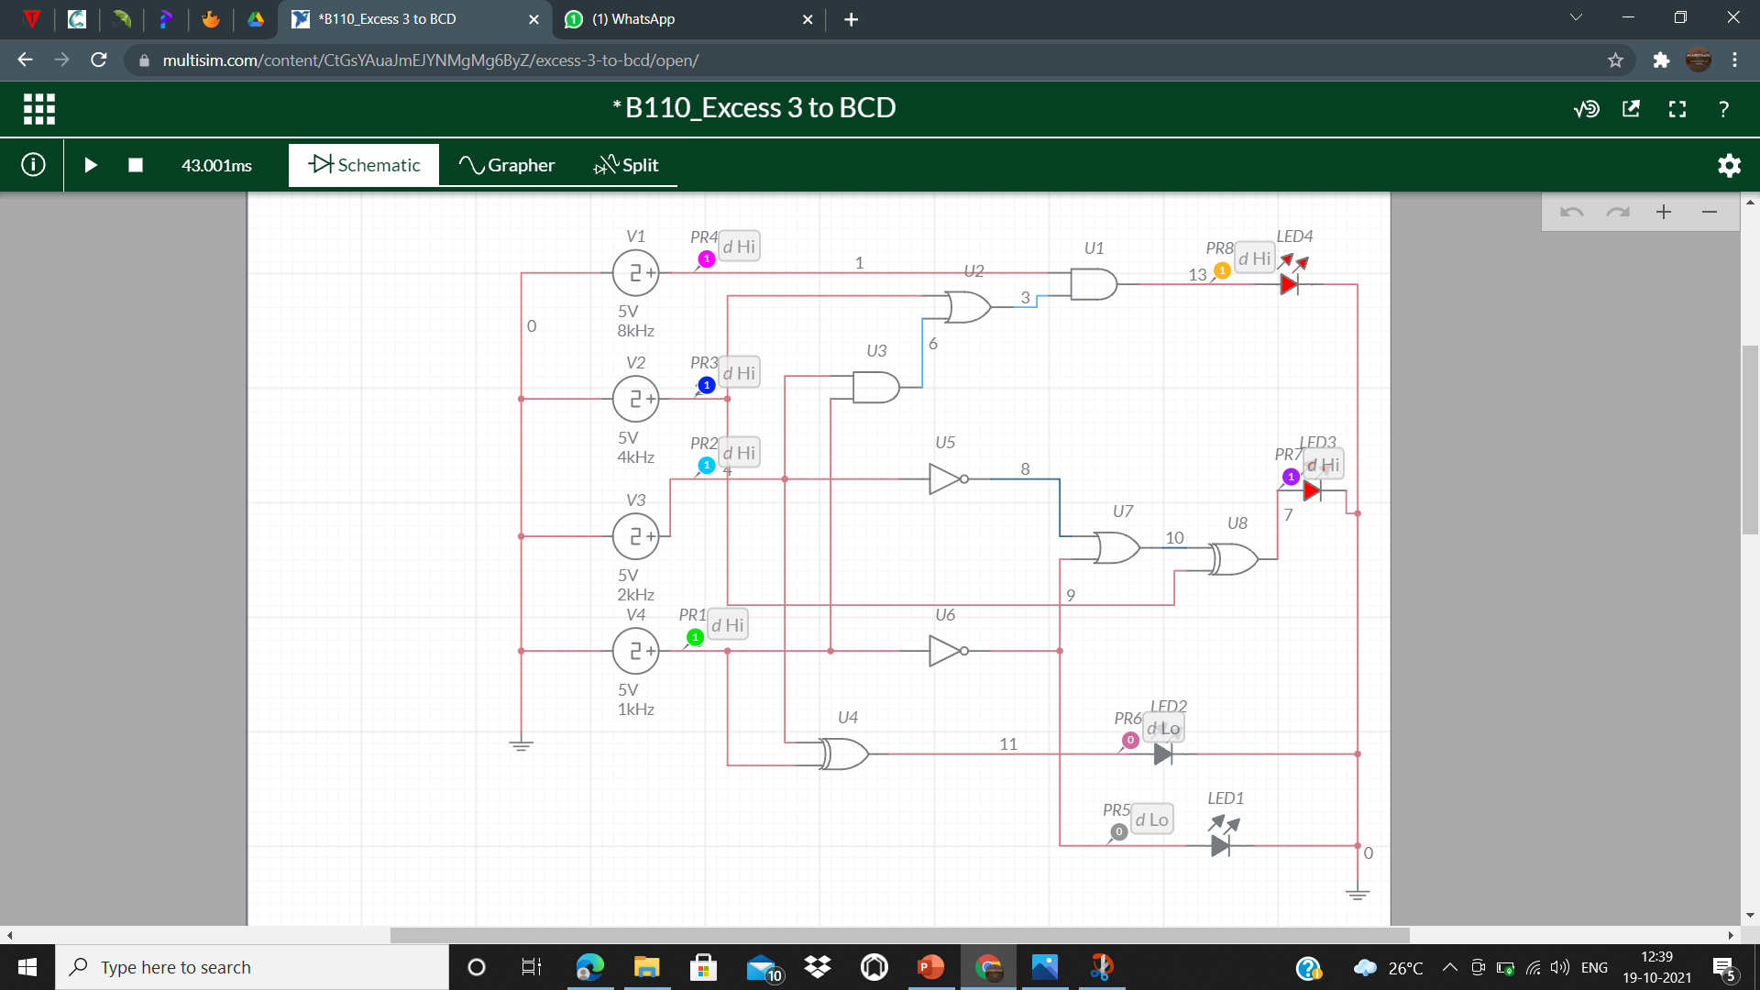

**EXCESS-3 TO BCD OUTPUT: -**

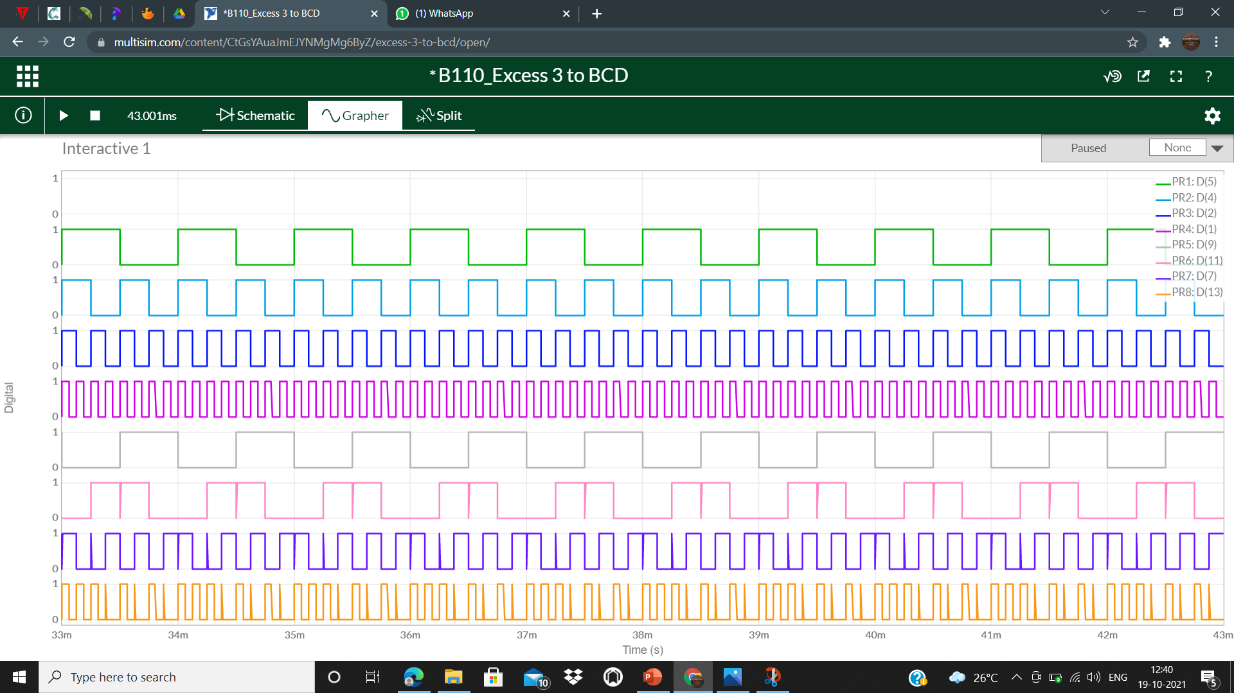

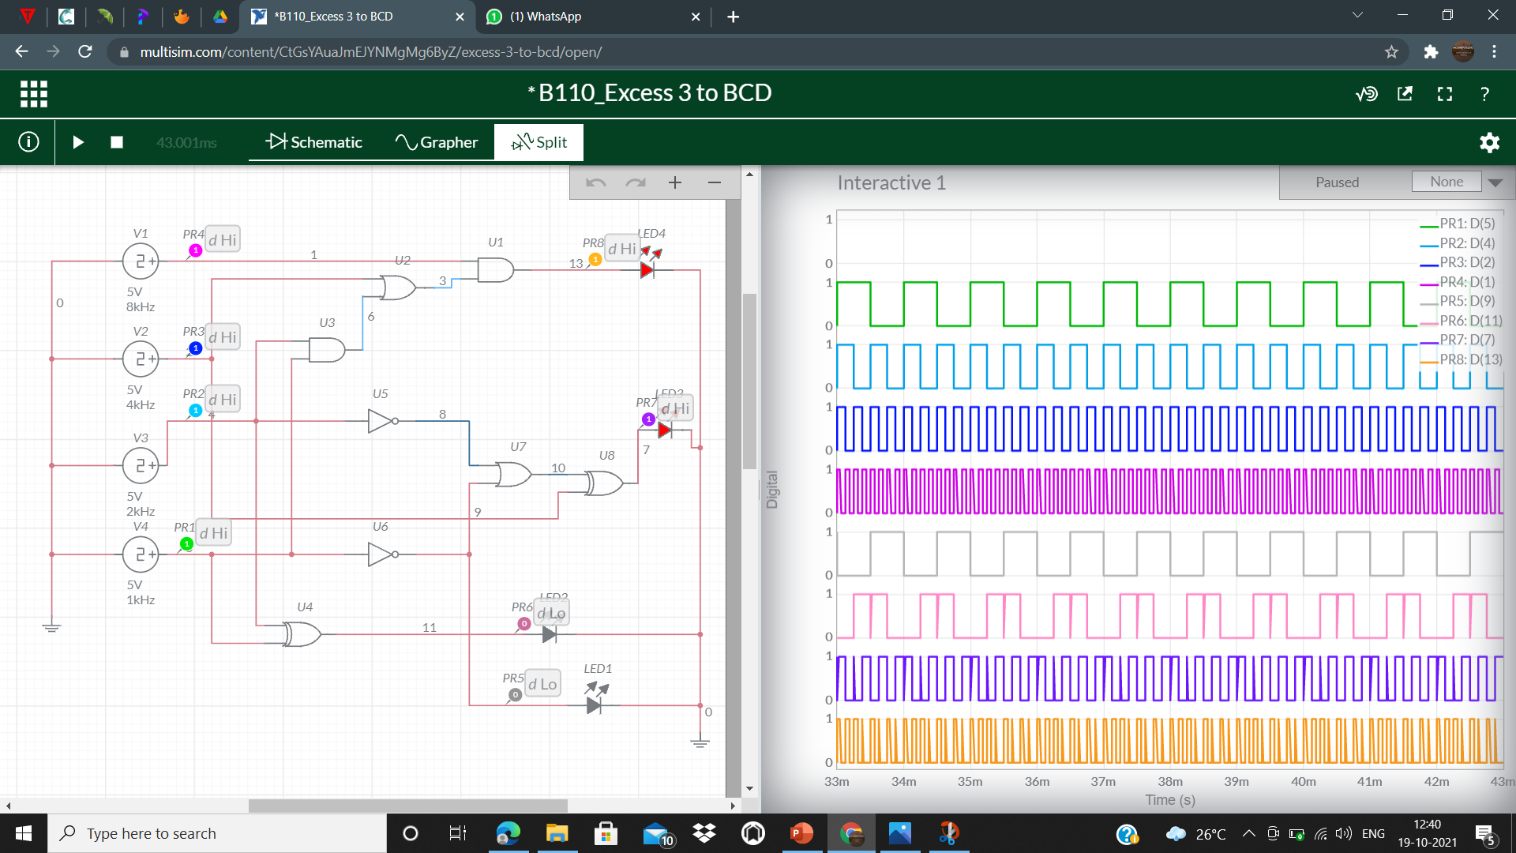

* **CONCLUSIONS :-**

## THE TRUTH TABLE IN THEORY AND THE SIMULATION OF THE BCD TO EXCESS-3 CODE CONVERTOR CIRCUIT AND VICE-VERSA CIRCUIT ON MULTISIM LIVE BOTH ARE EQUAL. HENCE VERIFIED.